Note: Below are the results obtained for the dataset with doing any pre-processing activity.

Rules 5:

Apriori

=======

Minimum support: 0.9 (960634 instances)

Minimum metric <confidence>: 0.9

Number of cycles performed: 2

Generated sets of large itemsets:

Size of set of large itemsets L(1): 3

Size of set of large itemsets L(2): 3

Size of set of large itemsets L(3): 1

Best rules found:

1. Quantity='(0-16199]' Country=United Kingdom 961222 ==> Price='(-7312.18-1944.256]' 961174 <conf:(1)> lift:(1) lev:(0) [83] conv:(2.68)

2. Quantity='(0-16199]' 1044418 ==> Price='(-7312.18-1944.256]' 1044356 <conf:(1)> lift:(1) lev:(0) [80] conv:(2.27)

3. Country=United Kingdom 981330 ==> Price='(-7312.18-1944.256]' 981212 <conf:(1)> lift:(1) lev:(0) [16] conv:(1.13)

4. Price='(-7312.18-1944.256]' Country=United Kingdom 981212 ==> Quantity='(0-16199]' 961174 <conf:(0.98)> lift:(1) lev:(0) [1062] conv:(1.05)

5. Country=United Kingdom 981330 ==> Quantity='(0-16199]' 961222 <conf:(0.98)> lift:(1) lev:(0) [994] conv:(1.05)

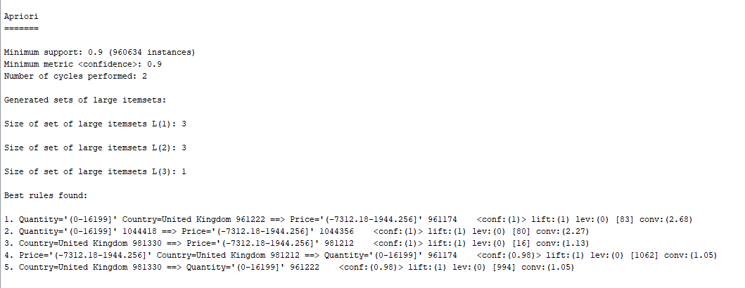

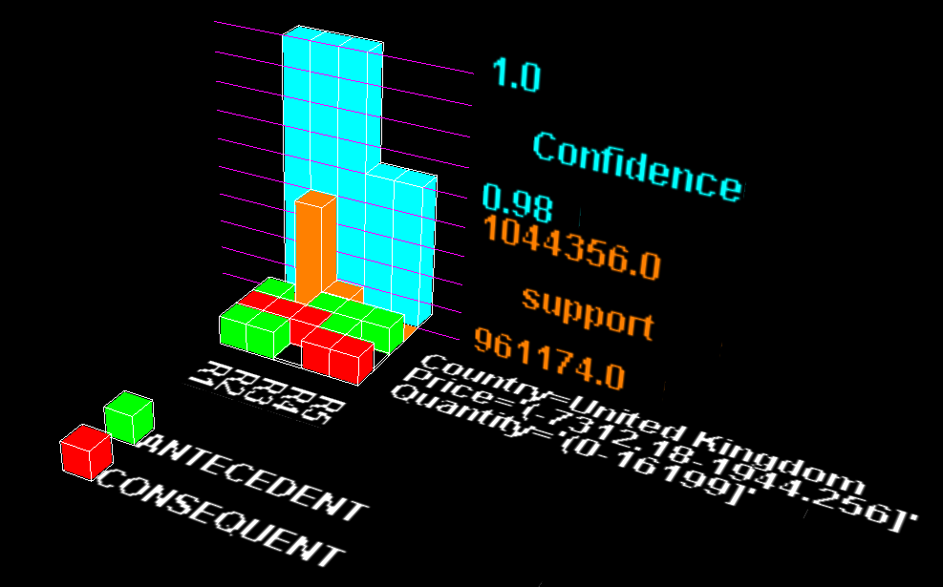

**Rule 10:**

Minimum support: 0.9 (960634 instances)

Minimum metric <confidence>: 0.9

Number of cycles performed: 2

Generated sets of large itemsets:

Size of set of large itemsets L(1): 3

Size of set of large itemsets L(2): 3

Size of set of large itemsets L(3): 1

Best rules found:

1. Quantity='(0-16199]' Country=United Kingdom 961222 ==> Price='(-7312.18-1944.256]' 961174 <conf:(1)> lift:(1) lev:(0) [83] conv:(2.68)

2. Quantity='(0-16199]' 1044418 ==> Price='(-7312.18-1944.256]' 1044356 <conf:(1)> lift:(1) lev:(0) [80] conv:(2.27)

3. Country=United Kingdom 981330 ==> Price='(-7312.18-1944.256]' 981212 <conf:(1)> lift:(1) lev:(0) [16] conv:(1.13)

4. Price='(-7312.18-1944.256]' Country=United Kingdom 981212 ==> Quantity='(0-16199]' 961174 <conf:(0.98)> lift:(1) lev:(0) [1062] conv:(1.05)

5. Country=United Kingdom 981330 ==> Quantity='(0-16199]' 961222 <conf:(0.98)> lift:(1) lev:(0) [994] conv:(1.05)

6. Country=United Kingdom 981330 ==> Quantity='(0-16199]' Price='(-7312.18-1944.256]' 961174 <conf:(0.98)> lift:(1) lev:(0) [1003] conv:(1.05)

7. Price='(-7312.18-1944.256]' 1067225 ==> Quantity='(0-16199]' 1044356 <conf:(0.98)> lift:(1) lev:(0) [80] conv:(1)

8. Quantity='(0-16199]' Price='(-7312.18-1944.256]' 1044356 ==> Country=United Kingdom 961174 <conf:(0.92)> lift:(1) lev:(0) [1003] conv:(1.01)

9. Quantity='(0-16199]' 1044418 ==> Country=United Kingdom 961222 <conf:(0.92)> lift:(1) lev:(0) [994] conv:(1.01)

10. Quantity='(0-16199]' 1044418 ==> Price='(-7312.18-1944.256]' Country=United Kingdom 961174 <conf:(0.92)> lift:(1) lev:(0) [1062] conv:(1.01)

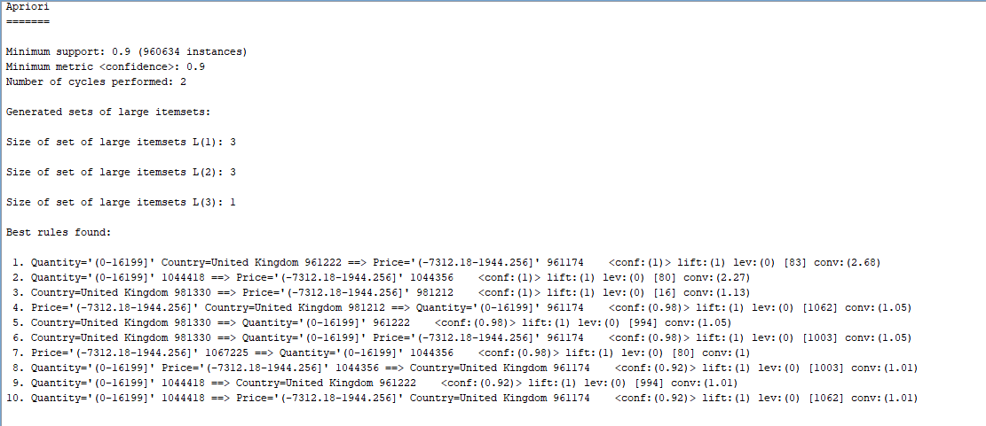

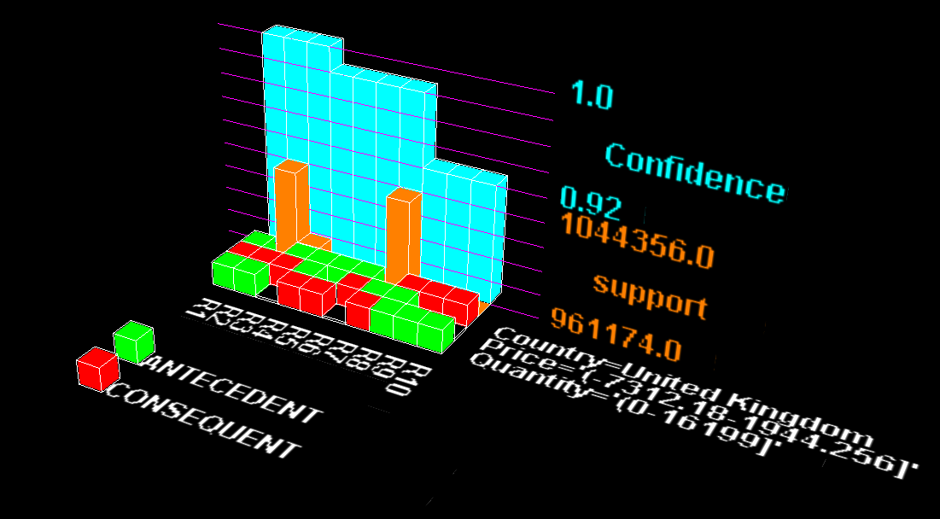

**Rule 20:**

**Apriori**

**=======**

Minimum support: 0.1 (106737 instances)

Minimum metric <confidence>: 0.9

Number of cycles performed: 18

Generated sets of large itemsets:

Size of set of large itemsets L(1): 3

Size of set of large itemsets L(2): 3

Size of set of large itemsets L(3): 1

Best rules found:

1. Quantity='(0-16199]' Country=United Kingdom 961222 ==> Price='(-7312.18-1944.256]' 961174 <conf:(1)> lift:(1) lev:(0) [83] conv:(2.68)

2. Quantity='(0-16199]' 1044418 ==> Price='(-7312.18-1944.256]' 1044356 <conf:(1)> lift:(1) lev:(0) [80] conv:(2.27)

3. Country=United Kingdom 981330 ==> Price='(-7312.18-1944.256]' 981212 <conf:(1)> lift:(1) lev:(0) [16] conv:(1.13)

4. Price='(-7312.18-1944.256]' Country=United Kingdom 981212 ==> Quantity='(0-16199]' 961174 <conf:(0.98)> lift:(1) lev:(0) [1062] conv:(1.05)

5. Country=United Kingdom 981330 ==> Quantity='(0-16199]' 961222 <conf:(0.98)> lift:(1) lev:(0) [994] conv:(1.05)

6. Country=United Kingdom 981330 ==> Quantity='(0-16199]' Price='(-7312.18-1944.256]' 961174 <conf:(0.98)> lift:(1) lev:(0) [1003] conv:(1.05)

7. Price='(-7312.18-1944.256]' 1067225 ==> Quantity='(0-16199]' 1044356 <conf:(0.98)> lift:(1) lev:(0) [80] conv:(1)

8. Quantity='(0-16199]' Price='(-7312.18-1944.256]' 1044356 ==> Country=United Kingdom 961174 <conf:(0.92)> lift:(1) lev:(0) [1003] conv:(1.01)

9. Quantity='(0-16199]' 1044418 ==> Country=United Kingdom 961222 <conf:(0.92)> lift:(1) lev:(0) [994] conv:(1.01)

10. Quantity='(0-16199]' 1044418 ==> Price='(-7312.18-1944.256]' Country=United Kingdom 961174 <conf:(0.92)> lift:(1) lev:(0) [1062] conv:(1.01)

11. Price='(-7312.18-1944.256]' 1067225 ==> Country=United Kingdom 981212 <conf:(0.92)> lift:(1) lev:(0) [16] conv:(1)

12. Price='(-7312.18-1944.256]' 1067225 ==> Quantity='(0-16199]' Country=United Kingdom 961174 <conf:(0.9)> lift:(1) lev:(0) [83] conv:(1)

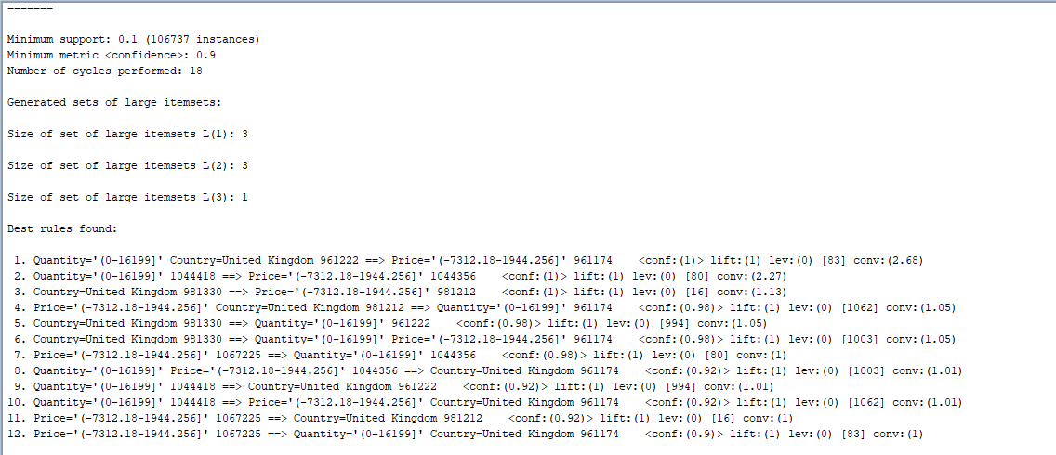

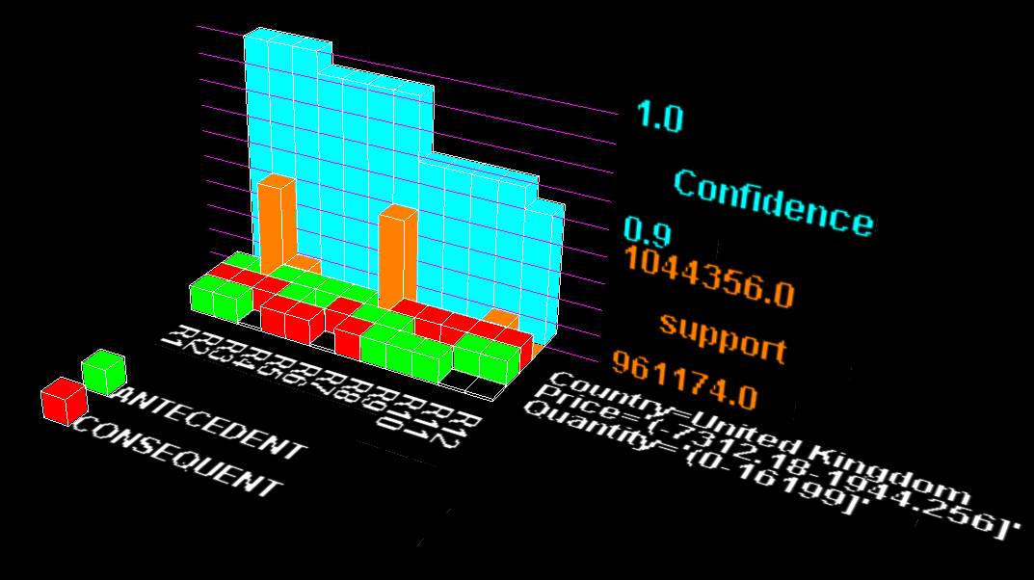

**Rules 15:**

Apriori

=======

Minimum support: 0.1 (106737 instances)

Minimum metric <confidence>: 0.9

Number of cycles performed: 18

Generated sets of large itemsets:

Size of set of large itemsets L(1): 3

Size of set of large itemsets L(2): 3

Size of set of large itemsets L(3): 1

Best rules found:

1. Quantity='(0-16199]' Country=United Kingdom 961222 ==> Price='(-7312.18-1944.256]' 961174 <conf:(1)> lift:(1) lev:(0) [83] conv:(2.68)

2. Quantity='(0-16199]' 1044418 ==> Price='(-7312.18-1944.256]' 1044356 <conf:(1)> lift:(1) lev:(0) [80] conv:(2.27)

3. Country=United Kingdom 981330 ==> Price='(-7312.18-1944.256]' 981212 <conf:(1)> lift:(1) lev:(0) [16] conv:(1.13)

4. Price='(-7312.18-1944.256]' Country=United Kingdom 981212 ==> Quantity='(0-16199]' 961174 <conf:(0.98)> lift:(1) lev:(0) [1062] conv:(1.05)

5. Country=United Kingdom 981330 ==> Quantity='(0-16199]' 961222 <conf:(0.98)> lift:(1) lev:(0) [994] conv:(1.05)

6. Country=United Kingdom 981330 ==> Quantity='(0-16199]' Price='(-7312.18-1944.256]' 961174 <conf:(0.98)> lift:(1) lev:(0) [1003] conv:(1.05)

7. Price='(-7312.18-1944.256]' 1067225 ==> Quantity='(0-16199]' 1044356 <conf:(0.98)> lift:(1) lev:(0) [80] conv:(1)

8. Quantity='(0-16199]' Price='(-7312.18-1944.256]' 1044356 ==> Country=United Kingdom 961174 <conf:(0.92)> lift:(1) lev:(0) [1003] conv:(1.01)

9. Quantity='(0-16199]' 1044418 ==> Country=United Kingdom 961222 <conf:(0.92)> lift:(1) lev:(0) [994] conv:(1.01)

10. Quantity='(0-16199]' 1044418 ==> Price='(-7312.18-1944.256]' Country=United Kingdom 961174 <conf:(0.92)> lift:(1) lev:(0) [1062] conv:(1.01)

11. Price='(-7312.18-1944.256]' 1067225 ==> Country=United Kingdom 981212 <conf:(0.92)> lift:(1) lev:(0) [16] conv:(1)

12. Price='(-7312.18-1944.256]' 1067225 ==> Quantity='(0-16199]' Country=United Kingdom 961174 <conf:(0.9)> lift:(1) lev:(0) [83] conv:(1)

